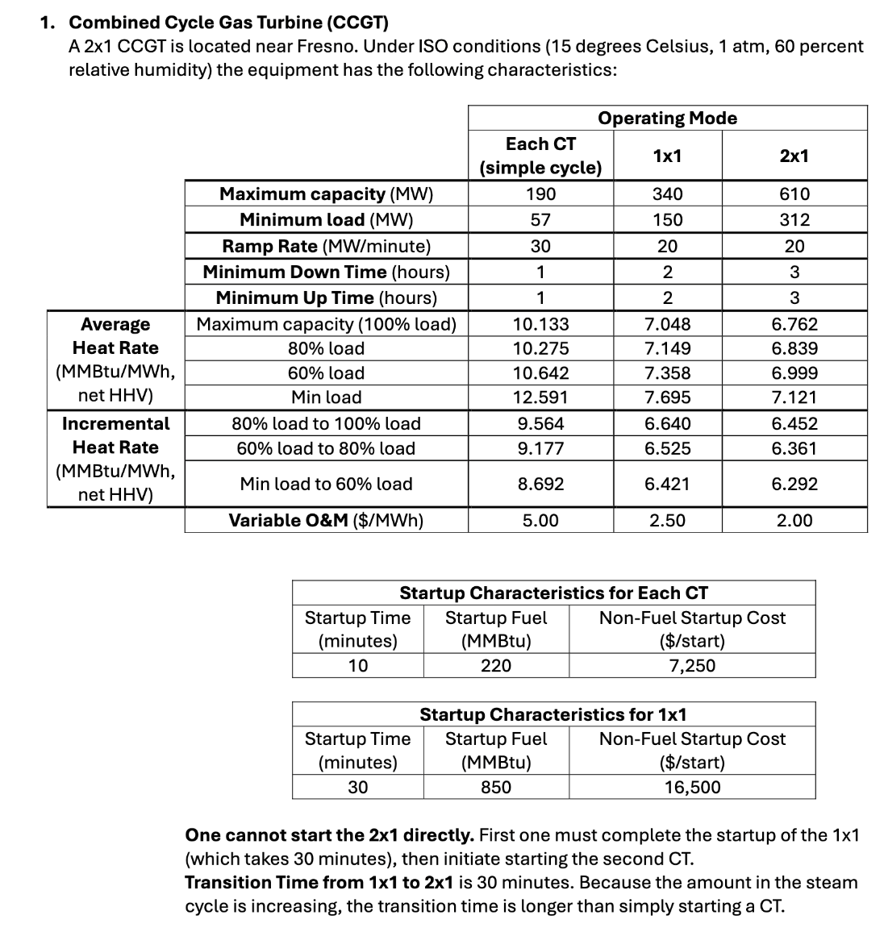
- The information abouut the CCGT provided above, and and the dataset, are insufficient to support optimization of the CCGT’s commitment/configuration/dispatch and a credible interpretation of results. For the 3 to 5 most consequential insufficiencies you identify, specify plausible assumptions that enable optimization of the CCGT’s commitment/configuration/dispatch and a credible interpretation of results.
- Assume Gas Price remains constant each day: Gas prices are shown daily while electricity prices are hourly. Assume gas price remains constant each day.
- Assume CO2 emission rate remains constant: The dataset provides CO2 price but no CO2 emission rate. Assume the emission rate remains constant throughout the optimization.
- Assume initial CCGT configuration starts with offline: The initial configuration of the CCGT is not specified. Assume the plant begins offline.

- OPTIONAL, EXTRA CREDIT: Obtain additional information and/or data to address one or more insufficiencies you identified in Task 1a. Describe the additional information and/or data you obtained and how it addresses the insufficiency. In performing Tasks 2, 3, and 4 below, use the additional information and data you have obtained.
Referencing lecture 9, slide 16, the carbon content of delivered natural gas is approximately 53 kg CO2 per MMBtu according to EIA and US EPA. This corresponds to 0.053 ton CO2/Mmbtu. This emission factor is assumed to remain constant throughout the simulation period.

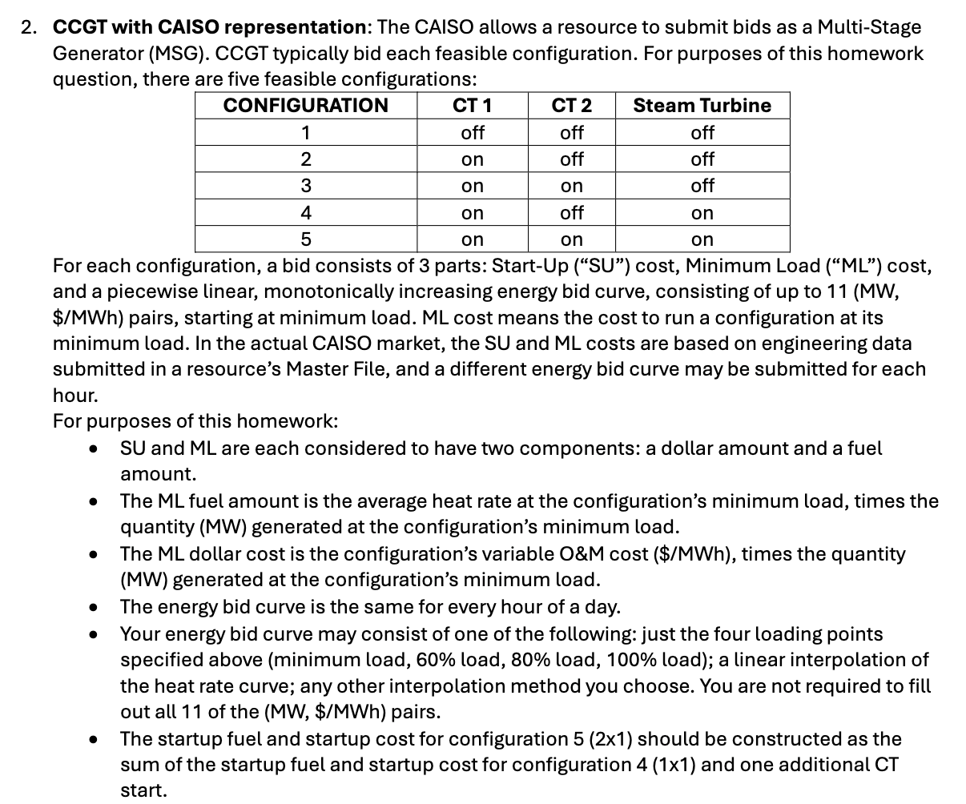
- For each configuration of the CCGT described in Task 1 above, fill in the following table:
Take the first day gas price = $7.05 into calculation.
Configuration 1: All Off
Configuration | 1
SU dollar ($/start) | $0
SU fuel (MMBtu/start) | 0
ML dollar ($/hour at minimum load) | $0
ML fuel (MMBtu/hour at minimum load) | 0
 | Energy Bid | MW | $/MWh
 | 1 | 0 | 0
 | 2 | 0 | 0
 | 3 | 0 | 0
 | 4 | 0 | 0

Configuration 2: 1 CT
Configuration | 2
SU dollar ($/start) | $7,250
SU fuel (MMBtu/start) | 220
ML dollar ($/hour at minimum load) | $285
ML fuel (MMBtu/hour at minimum load) | 717
 | Energy Bid | MW | $/MWh
 | 1 | 57 | $112.65
 | 2 | 114 | $95.99
 | 3 | 152 | $92.85
 | 4 | 190 | $91.64

Configuration 3: 2 CT
Configuration | 3
SU dollar ($/start) | $14,500
SU fuel (MMBtu/start) | 440
ML dollar ($/hour at minimum load) | $375
ML fuel (MMBtu/hour at minimum load) | 1154
 | Energy Bid | MW | $/MWh
 | 1 | 150 | $68.29
 | 2 | 204 | $65.41
 | 3 | 272 | $63.62
 | 4 | 340 | $62.76

Configuration 4: 1 CT + 1 Steam (1 x 1)
Configuration | 4
SU dollar ($/start) | $16,500
SU fuel (MMBtu/start) | 850
ML dollar ($/hour at minimum load) | $375
ML fuel (MMBtu/hour at minimum load) | 1154
 | Energy Bid | MW | $/MWh
 | 1 | 150 | $68.29
 | 2 | 204 | $65.41
 | 3 | 272 | $63.62
 | 4 | 340 | $62.76

Configuration 5: All on – 2 CT + 1 steam (2 x 1)
Configuration | 5
SU dollar ($/start) | $23,750
SU fuel (MMBtu/start) | 1070
ML dollar ($/hour at minimum load) | $624
ML fuel (MMBtu/hour at minimum load) | 2221
 | Energy Bid | MW | $/MWh
 | 1 | 312 | $62.88
 | 2 | 366 | $61.84
 | 3 | 488 | $60.47
 | 4 | 610 | $59.81

- Describe, in words and mathematically, any calculations you perform to obtain the numbers you provided in Task 2.a.
- The startup fuel and startup cost for Configuration 5 (2x1) are calculated as the sum of the startup fuel and startup cost for Configuration 4 (1x1) and one additional CT.
- ML dollar cost = Variable O&M x Minimum load
- ML fuel = Min Average Heat Rate x Minimum load
- Energy Bid Curve is calculated based on % with respect to Maximum capacity
- $/MWh = (Average Heat Rate x Gas Price[first day gas price]) + (Average Heat Rate x 0.053 x CO2 price) + VOM

- For the operating period March 21-27, 2022, determine an operating plan that maximizes the CCGT’s total revenues minus total operating costs.
    - Specify your formulation, in words and mathematically. Specify decision variables, objective, constraints, and assumptions.
Hours: t ∈ T = {1, …, 168}
Configuration: c ∈ C = {1, 2, 3, 4, 5}
Objective:

Where:
Ptelec = electricity price in hour $t$
$FuelCost_{t}$= fuel cost in hour $t$
$StartupCost_{t}$= startup cost in hour $t$
$VOM_{t}$= variable O&M cost in hour $t$

Decision Variables:
- yc,t ∈ {0, 1}: equals 1 if configuration $c$is active in hour $t$, 0 otherwise
- sc,t ∈ {0, 1}: equals 1 if configuration $c$starts up in hour $t$, 0 otherwise
- gt: total MW generated at time t
Contraints:
- Generated electricity has to be bigger equal to 0: gt >= 0
- Only one configuration can be activate each hour
- Generation must stay within the minimum and maximum output of the chosen configuration
- $s_{c,t}=1$when configuration $c$is newly turned on
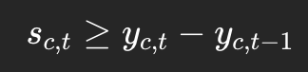
Assumptions:
- Gas price is constant within each day
- Electricity revenue is based on hourly generation times hourly electricity price
- Only one feasible configuration can be active in each hour, including the off configuration
- Startup costs are incurred when the model switches from an inactive state to an active configuration
- Generation within each configuration is bounded by the configuration’s minimum and maximum capacity
    - Provide a link to the Python code you used to perform your optimization. NOTE: Use a Mixed-Integer Linear Programming (MILP) solver stack (any solver / package is acceptable).

    - In a CSV file named CCGT_CAISO in your repository, provide the following for each hour in the 168-hour operating period: OPERATING_DATE, HOUR_ENDING, PRICE_ELECTRIC, PRICE_GAS, CONFIGURATION_ACTIVE, MW_GENERATION. In your pdf write-up, display the first 12 hours of your CSV file and provide a link to your CSV file.
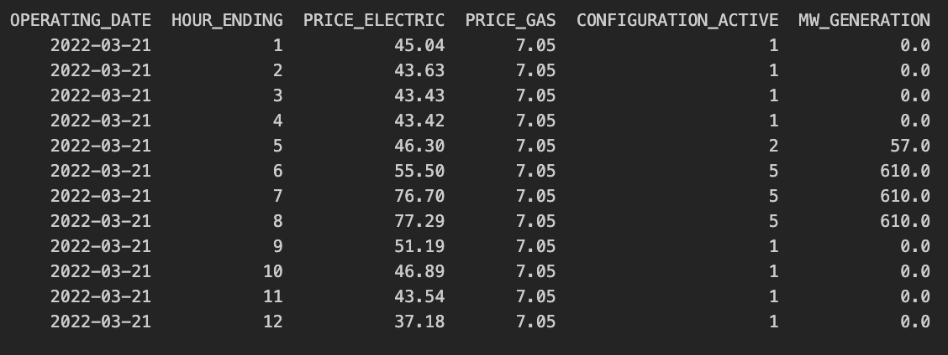
    - Display a plot of MW vs. hour, for the 168-hour operating period.
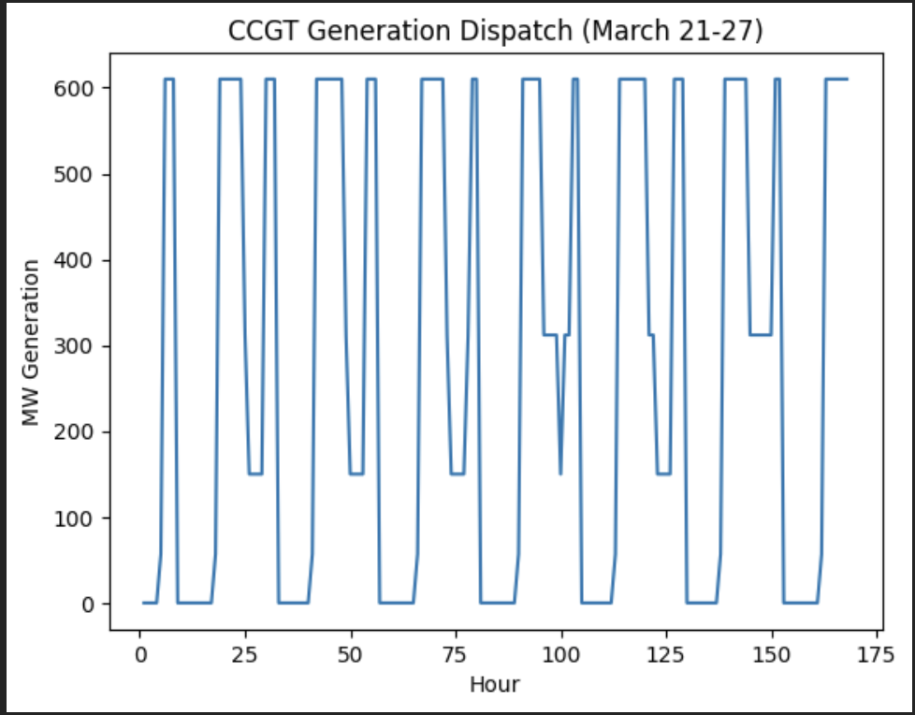

    - Display a plot of configuration mode vs. time for the operating period.
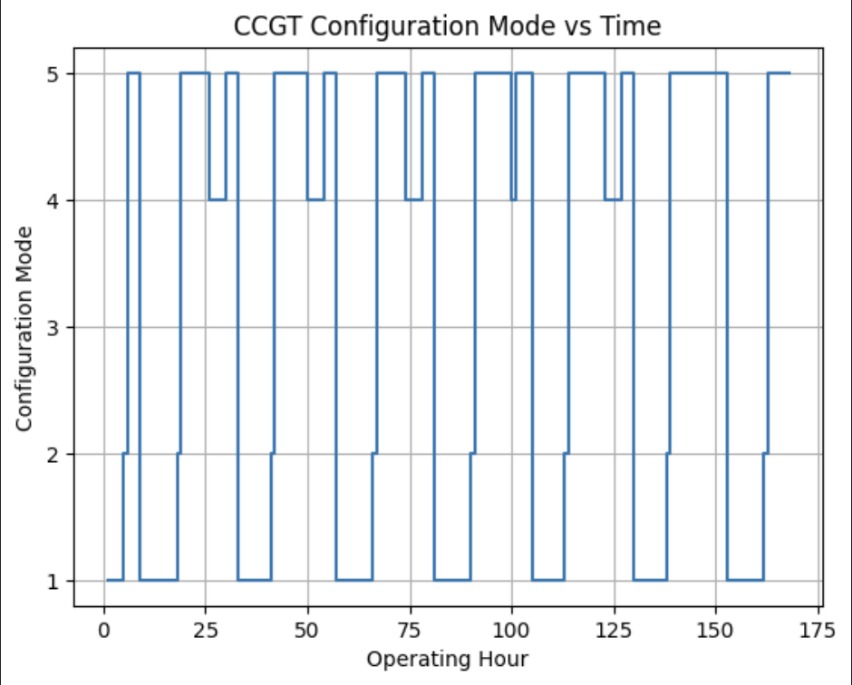
    - For the operating period, provide the following: Gross Margin (in $/kW), Capacity Factor (%), Total Revenue ($), Total Costs ($), Fuel Costs ($), and Number of Starts
Gross Margin (in $/kW) | 0.96
Capacity Factor (%) | 44.72%
Total Revenue ($) | $ 3,095,982.18
Total Costs ($) | $ 2,511,536.63
Fuel Costs ($) | $ 2,359,229.63
Number of Starts | 8

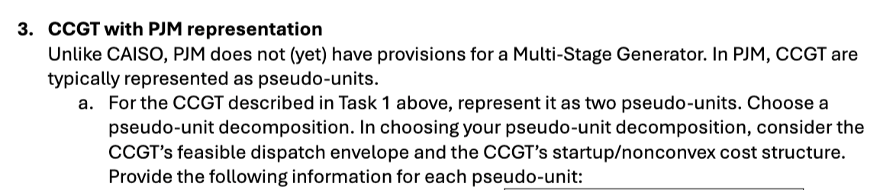

Side Note:
- Formulate MILP to maximize plant operations: Max(Reveneue – Costs)
  - Decision variables:
    - Binary variable: whether the plant is on/off
    - Continuous variable: how much electricity to generate
  - Revenue: Electricity price x MW
  - Costs: Gas cost (heat rate x gas price x MW) + variable O&M + CO2 cost (heat rate x 0.053 x CO2 price)+ startup cost
- 5 configurations (settings):
  - All turn off
  - 1 CT
  - 2 CT
  - 1 CT + Steam Turbine (1 x 1)
  - 2 CT + Steam Turbine (2 x 1) (All on)
- Energy Bid Curve:
  - At this generation level, this is the price I require to produce electricity
  - From Max to Min Load: 11 Bid Curve

